


THE REAL SCHOOL
LEARNER’S EMPOWERMENT ACTIVITIES
P.6 TERM I 2025 SOCIAL STUDIES
EAST AFRICAN COMMUNITY

Victoria P/S

Golden Junior
School

Makindye Junior School

An excellent first grade and excellent character for every pupil

NAME………………………………………………………………………CLASS: …………………………
SCHOOL: ……………………………………………………………………………………………………….

THEME: LIVING TOGETHER IN EAST -----------------
TOPIC: EAST ------------------ COMMUNITY

SUB TOPIC: REVIVAL OF THE EAST AFRICAN COMMUNITY
Use the map below to fill in the above gaps
Draw the map of Africa below

SESSION 6
ATTEMPT ME AFTER THIS SESSION

1. Identify any two colours of the Uganda flag.
i) _____________________________________ ii) _____________________________________
2. What do the following symbols represent.
industrial wheel _______________________________________________________________
arch of leaves __________________________________________________________________
hand shake __________________________________________________________________
3. What do the following mean?
JUMUIYA YA AFRIKA ________________________________________________________
MASHARIKI _________________________________________________________________

REVIVAL OF THE EAST AFRICAN COMMUNITY IN 2001.

The final agreement to revive the ------------------- was signed on 30th November,1999. (Write EAC in full)

It was signed at Amri Abeid Memorial stadium in ______________. (Tanzania, Uganda)

Note: The East African Community was called the East African Cooperation from 1993-1999.

Presidents who revived the East African Community.
- Yoweri K. Museveni of ----------------.
- Benjamin Mkapa of ---------------------.
- Daniel Arap Moi of -----------------.

[ Uganda, Kenya and Tanzania]

HANDS ON ACTIVITY
Name any two departments of EAC that survived its collapse.
i) _____________________________________ ii) _____________________________________
Give any two problems that were faced by EAC
i) ____________________________________________________________________________
ii) ____________________________________________________________________________
Where was the final agreement of the revival of EAC signed?
_____________________________________________________________________________
Name any two presidents that revived the EAC
i) ____________________________________ ii) _____________________________________
How was the EAC called between 1993 to 1999?
_______________________________________________________________________

Reasons why the East African Community was revived.

Use the words in brackets to fill in the spaces below.

- To have common ________ on goods. [taxes, funds]
- To reduce smuggling of ----------. [good, goods]
- To have a common ----------- in East Africa. [language, currency]
- To promote -------- and security in the region. [peace]
- To promote -------------- and unity among the member states. [cooperation, togetherness]
- To promote easy movement of people and goods across ----------- of the member states. [boarders]
- To reduce on ----------- barriers. [trade, goods]

The Expansion of the East African Community
- Rwanda in ---------
- South Sudan in ----------
- Burundi in ----------
- DRC in ------------
- Somalia in ------------
2016, 2007, 2022, 2024

Reasons why Rwanda, Burundi and South Sudan joined the East African Community.
- To easily handle oversea goods through port ----------- and Mombasa.
- To enjoy free movement of people and ------ among member states.
- To get a wider ---------- for their goods.
- To get some goods they do not produce.
- To promote ----------- and friendship with their neighbours.

[ Dar-es-salaam, goods, market, cooperation]

HANDS ON ACTIVITY
Given any two reasons as to why the EAC was revived?
i) ____________________________________________________________________________
ii) ____________________________________________________________________________
In which year did the following countries join the EAC
Somalia ____________________________________________________________________
South Sudan ____________________________________________________________________
Give any two reasons why Ethiopia joined the EAC
i) ____________________________________________________________________________
ii) ____________________________________________________________________________
Name the two countries that joined EAC in 2007.
i) _________________________________ ii) ______________________________________

The current member states of the East African Community.
Country | Capital City | President | Currency Used | Area of land (km2)
Tanzania | ---------------- | John Pombe Magufuli | Tanzanian shilling | 945,087
---------- | Kampala | Yoweri Kaguta Museveni | Ugandan shilling | 241,037
Kenya | ------------- | Uhuru Kenyatta | Kenyan shilling | 580,367
Rwanda | Kigali | Paul Kagame | Rwandan Franc | 26,338
Burundi | ----------------- | ------------------- | Burundian Franc | 27,834
South Sudan | Juba |  | South Sudanese pound | 619,745

Use the words below to complete the table.

(Dodoma, Gitega, Nairobi, Evariste Ndayishimiye, Salva Kiir Mayardt, Uganda)

Note:
-The largest country among the ______________ member states is Tanzania. (EAC, EA)
-The smallest country among the EAC member states is Rwanda.

A map showing the location of the current East African Community member states.

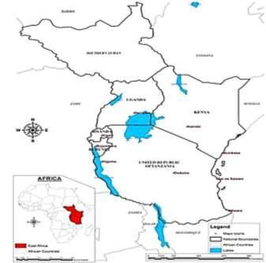

South Sudan

Kenya

Tanzania

Uganda

Ethiopia

Sudan

Democratic

Republic of

Congo

Zambia

Malawi

Mozambique

Indian ocean

Somalia

Benefits of the East African Community.

To an individual/ people of East Africa.
(opportunities, countries, traders, borders, imported)
- It has created employment -------------- for people.
- People are able to get goods that is not produced in their----------------.
- It has widened market for ----------- goods.
- It has allowed free movement of people and goods across----------.
- It has reduced taxes imposed on their -------------- goods.

b) To member states of EAC.
[unity, stability, wider, sea ports]
- It has promoted cooperation and -------------among member states.
- It has promoted peace and ------------- in the member states.
- It has created a ------------ market for goods produced in the member states.
- It has enabled land locked member states to access -----------

To non-member states of EAC.
- It has created a wider market for their goods.
- The EAC member countries provide --------- labour to non-member states of EAC.
- The EAC member countries provide -----------to non-member states of EAC.
- The EAC member states provide ----- to people from non-member states of EAC.
( security, jobs, skilled)
ATTEMPT ME PLEASE

Mini activity
Complete the table below
president | country | currency | Capital city
HE.Yoweri kaguta Museveni | Uganda | __________________ | kampala
___________________ | Rwanda | ___________________ | kigali
Evariste Ndayishimiye | _________________ | Burundian franc | Gitega.
State any two benefits of the following.
a)individuals
____________________________________________________________________________________________________________________________________________________________
b)nonmember states countries
____________________________________________________________________________________________________________________________________________________________
Member states
____________________________________________________________________________________________________________________________________________________________
MEGA ACTIVITY
1. Mention any reasons for the collase of the EAC community
____________________________________________________________________________________________________________________________________________________________
2. Name the head of states by the time EAC collapsed?
Uganda__________________________________________________
Tanzania_________________________________________________
3. State any two problems that were faced by East African countries after the collapse of EAC
____________________________________________________________________________________________________________________________________________________________
4. Give any two departments that survived the collapse of the EAC?
____________________________________________________________________________________________________________________________________________________________
5. Mention any two problems that were faced by the EAC
____________________________________________________________________________________________________________________________________________________________
6. Name any two presidents of the East Africa who were presidents by the time EAC was revived?
____________________________________________________________________________________________________________________________________________________________
7. Write brief notes about Amri Abed memorial stadium
____________________________________________________________________________________________________________________________________________________________
8. State any one reason why the EAC was revived?
____________________________________________________________________________________________________________________________________________________________
9. Give any two benefits of EAC to the individuals
____________________________________________________________________________________________________________________________________________________________
RASEARCH
Give the meaning of a landlocked country
give the meaning of a non-landlocked country?
how are sea ports important to member states of EA?

LANDLOCKED COUNTRIES AND NON-LANDLOCKED COUNTRIES

How I will be able to use this knowledge in daily life (relevance)
From this session I will gain know ledge which will as well help me to relate with real life situation for example understanding how impactful Kenya is important to Uganda in terms of trade

Competences
- Landlocked member states of the EAC
- Problems faced by landlocked countries
- Possible solutions to the problems
- Non landlocked countries
- Major seaports that handle EAC goods
- Benefits enjoyed the non-landlocked countries.

What I already know (background knowledge)
In relation with previous classes about landlocked countries
What are landlocked countries?
Examples of landlocked countries?
non landlocked countries?

Key learning principles
Landlocked……………………………..without sea port
non landlocked ………………………with a sea port
challenges………………………………problems
seaport…..coastline

Learner centered approach
Imagine if you want to carryout trade with European or Asian countries with the cheapest means of transport which is water transport but your country doesn’t have seaport.
What name is used to define a country without a seaport?
______________________________________________________________________________
State any two possible solutions you can use in order to carryout trade?
____________________________________________________________________________________________________________________________________________________________

CONTENT

LAND LOCKED MEMBER STATES OF THE EAC

A land locked country is a country without a ------------. [seaport, sea port]

Land locked countries are completely surrounded by other countries.

Member states of EAC which are land locked.
Uganda • --------------------
Burundi • South Sudan

(Uganda’s neighbour in the Southwest)

Neighbouring countries of the EAC which are land locked.

Ethiopia • Zambia
Malawi • Central ------------- Republic (C.A.R)

Problems faced by land locked countries.
[transit, imported, exporting, prices]

- Delay of oversea goods in--------.
- High taxes charged on -----------oversea goods.
- High transport costs when importing and --------------- goods.
- High ---------- for imported goods

Possible solutions for the above challenges.
(industrial, countries, grouping, modern, importing)
- By joining the regional----------------.
- By improving on the air transport system.
- By encouraging local ----------production.
- By cooperating with non-land locked----------.
- By building ------road networks.
- By using various sea ports when ----------- and exporting goods.

HANDS ON ACTIVITY
Give the meaning of a landlocked country?
____________________________________________________________________________________________________________________________________________
Mention any two member states of the EAC that are landlocked?
______________________________________________________________________________________________________________________________________
Write down any two problems faced by landlocked countries?
____________________________________________________________________________________________________________________________________________
Mention any two solutions to the above problems?
____________________________________________________________________________________________________________________________________________

MINI ACTVITY
What do you understand by a landlocked country?
__________________________________________________________________________________________________________________________________________________________
State any two members of the EAC that are non-landlocked?
____________________________________________________________________________________________________________________________________________________________
Give any two major Seaports that handle EastAfrica’s goods
____________________________________________________________________________________________________________________________________________________________
mention any two benefits enjoyed by the non-landlocked countries?
____________________________________________________________________________________________________________________________________________________________
MEGA ACTIVITY
Give the difference between non landlocked countries and landlocked countries?
____________________________________________________________________________________________________________________________________________________________
Name the sea port that handles most of the East Africa imports?
_____________________________________________________________________
Why does Uganda use the above sea port to export and import her goods instead of other ports?
______________________________________________________________________________
Mention any two benefits enjoyed by the non-landlocked countries?
____________________________________________________________________________________________________________________________________________________________
Name any two EAC Member states that are crossed by the Equator?
______________________________________________________________________________
______________________________________________________________________________
How do people enjoy the benefits of the EAC
_____________________________________________________________________________
7.Name the major seaport of DRC that handles its imports and exports?
______________________________________________________________________________
Mention any two problems that were faced by countries without Seaports?
____________________________________________________________________________________________________________________________________________________________
Write down any two ways how the above problems can be solved?
____________________________________________________________________________________________________________________________________________________________
PROJECT WORK
Using an atlas, pencil and paper, draw a Map of the East African community and name the member states.
RESEARCH WORK
Give any two organs of the EAC
Who heads the summit?
What is the role of the summit?

WHAT I WILL BE ABLE TO KNOW (LEARNING OUTCOME)
Develops an appreciation of the importance of the East African community and applies the acquired knowledge in daily life

SYMBOLS OF EAC

HOW TO USE THIS KNOWLEDGE IN MY DAILY LIFE (RELEVANCE):
National symbols can unite citizens/learners and promotes a sense of shared values and goals.

Competences.
- Identifies symbols of the current countries of the EAC
- Uganda, Kenya, Rwanda, Burundi, South Sudan DRC, Somalia

WHAT I ALREADY KNOW (BACKGROUND KNOWLEDGE)
The organs of EAC their roles and activities.
Symbols of a nation

Key learning principle.
Symbols are unique meanings that represent an idea, concept or an object

Learner centred approach.
- Imagine you are going for a sports gala, where there are many schools attending. Mention any three things that you would carry along in order to ease identification or ensure order.
CONTENT
SYMBOLS OF THE EAST AFRICAN COMMUNITY.
- The EAC flag
- The EAC ------------
- The EAC constitution
- The EAC -------------
- The EAC emblem
Use the words below to complete the above examples.

(anthem, motto)

The East African Community Flag
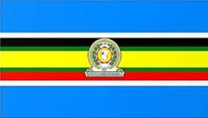 | - The EAC has ------- colours and an emblem in the middle.  - The Blue background represents the waters of lake -----------. [inter territorial lake]  - White, ------------, Green, Yellow, and Red colours are taken from the flags of the EAC member states to signify their cooperation. [Black]

Places where the EAC flag can be raised.
- Schools • Airports
- Embassies and High Commissions of the • Hospitals
Member States • Public offices

Note:-The EAC motto is--------------. It encourages unity among people of the EAC. (One People One Destiny)

Importance of the EAC flag.
(regional, patriotism, identity)
- It promotes ----------- unity.
- It promotes--------------.
- It promotes regional------------.

The EAC emblem.

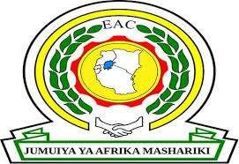 | - A Map of East Africa in the middle of the EAC emblem. It reminds of the EAC cooperation.  - The ------------ represents the industrial growth as a common goal in the region.  - The ------------represents the rich vegetation and agricultural production among the member states.  - The ------------ represents unity and friendship among the member states.  - The words “JUMUIYA YA AFRIKA  MASHARIKI” translated as “East African Community” means the cooperation of the countries of East Africa.  [industrial wheel, arch of leaves, hand shake]

Hands on activity.
1. Identify any two colours of the Uganda flag.
i) _____________________________________ ii) _____________________________________
2. What do the following symbols represent.
industrial wheel _______________________________________________________________
arch of leaves __________________________________________________________________
hand shake __________________________________________________________________
3. What do the following mean?
JUMUIYA YA AFRIKA ________________________________________________________
MASHARIKI _________________________________________________________________

THE EAST AFRICAN COMMUNITY ANTHEM.
It is called Wimbo wa Jumuiya ya Afrika Mashariki.
The EAC anthem started to be used on 3rd December 2010. It has three stanzas.
It was composed by;
  - John Mugango from Tanzania.
  - Wasswa Joseph from Uganda.
Richard Kadhambi from Kenya.

Occasions where EAC anthem is sung
  - School assemblies ▪ At official ceremonies ▪ During parliamentary sessions.
▪ Start of public functions.

Importance of the EAC anthem.
[regional, patriotism, states]
- It promotes -------------- unity.
- It promotes ----------- and hard work.
- It promotes love for God.
- It promotes friendship among the EAC member------------.

EAST AFRICAN COMMUNITY ANTHEM
Kiswahili Version English Version

Stanza 1 Stanza 1
Ee Mungu twaomba ulinde Oh God we pray
Jumuiya Afrika Mashariki For preservation of the East African
Tuwezeshe kuishi kwa amani Community;
Tutimize na malengo yetu Enable us to live in peace;
May we fulfill our objectives;

Chorus
Jumuiya Yetu sote tuilinde Chorus
Tuwajibike tuimarike We should protect/guard our community
Umoja wetu ni nguzo yetu We should be committed and
Idumu Jumuiya yetu. Stand strong
Our unity is our anchor
Stanza 2 Long live our community
Uzalendo pia mshikamano
Viwe msingi wa Umoja wetu Stanza 2
Natulinde Uhuru na Amani Patriotism and togetherness
Mila zetu na desturi zetu. Be the pillars of our unity
May we guard our independence
Stanza 3 And peace
Viwandani na hata mashambani Our culture and traditions
Tufanye kazi sote kwa makini
Tujitoe kwa hali na mali Stanza 3
Tuijenge Jumuiya bora. Industries and farms
We should work together We should work hard
We should build a better community.
MINI ACTIVITY
- Match correctly.
i) Features of the EAC Emblem | What they represent.
ii) Industrial wheel | unity and friendship
iii) Arch of leaves | industrial growth
iv) Hand shake | rich vegetation and agricultural production
v) The map | EAC cooperation
i) Features of the EAC Emblem _______________________________________________
ii) Industrial wheel _________________________________________________________
iii) Arch of leaves ___________________________________________________________
iv) Hand shake _____________________________________________________________
v) The map ________________________________________________________________

- Draw and shade the flag of the EAC in the space below.

- Mention any three importance of the EAC anthem.
i) __________________________________________________________________________
ii) _________________________________________________________________________
iii) _________________________________________________________________________

UGANDA’S NATIONAL SYMBOLS
THE UGANDA NATIONAL FLAG
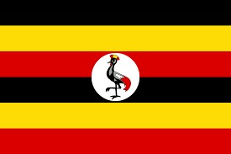 | - The Uganda National Flag was designed by ----------- Ibingira. (Grace, George)  - The Uganda national flag has --------- main colours  i.e. black ,yellow ,red.  - A ------- crane in a white circular background is at the centre of the flag. The white background represents peace. (crested, flamingo)  - The Uganda national flag promotes national identity.

Meaning of each colour on the Uganda National Flag.
- Black represents the ---------- people of Uganda. It symbolises the African race of Ugandans. [dark-skinned]
- Yellow represents the –--------- sunshine received in Uganda. [abundant]
It also represents the -------- climate experienced in Uganda. [warm, cold]
- Red represents the international--------------. [brotherhood]
- White stands for the peace enjoyed in Uganda.

THE UGANDA NATIONAL COAT OF ARMS.
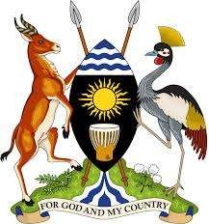 | - Uganda coat of arms is composed of a shield and two spears on a green hill with the Uganda kob on the left and the crested crane on the right. It is designed using symbols that summarise important ideas and things Uganda holds.  - It is found on official documents, the national currency, parliament, the government seal and the president’s official car.  - It is also hung in government institutions like courts and offices to symbolise power and authority.  - The Uganda coat of arms was designed by Paul Mukasa.  - The Uganda coat of arms acts as a public seal of Uganda.  - The public seal is used to signify the official nature of government documents that bear its stamp.

Meaning of features found on the Uganda coat of arms.

[The spears and shield, Coffee and cotton, The blue stripes at the, The black colour, The blue stripes at the bottom]
- -------------- represents the traditional means of defence.
- ---------------------top represents the water bodies in Uganda.
- --------------------- of the shield represent the source of River Nile found in Uganda.
- The sun represents the abundant sunshine received in Uganda or warm climate experienced in Uganda.
- The drum represents the traditional means of communication.
It also represents the culture of the people of Uganda.
- -------------------- on the shield symbolises the African race of Ugandans.
- The kob represents the rich/abundant wildlife in Uganda.
- The crested crane represents the gentleness and peaceful nature of the people of Uganda.
- -------------- on the green hill show the traditional cash crops grown in Uganda.
It also shows that Uganda is an agricultural country.
- The green colour represents the abundant vegetation of Uganda.
- The green hill represents the many physical features of Uganda.
- The national motto “For God and My Country” signifies that the people of Uganda are God fearing.

MINI ACTIVITY.
- Study the diagram below and answer questions that follow.

- What do the symbols above represent?
____________________________________________________________________________
Complete the sequence below
- The spears and shield ------------------------------------------------------------------------------------
- The blue stripes at the top____________________________________________________
- The blue stripes at the bottom of the shield represent the source of River Nile found in Uganda.
- The sun -------------------------------------------------------------------------------------------------------
- ___________________ represents the traditional means of communication.
It also represents the culture of the people of Uganda.
- The black colour on the shield symbolises the ___________________________________
- The kob represents the rich/abundant wildlife in Uganda.
- The crested crane ____________________________________________________________
- Coffee and cotton on the green hill show the traditional cash crops grown in Uganda.
It also shows that Uganda is an agricultural country.
- The green colour -------------------------------------------------------------------------------------------
- The green hill -----------------------------------------------------------------------------------------------
- The national motto “For God and My Country” signifies that the people of Uganda are God fearing.
- Draw and shade the Uganda national flag

TH E UGANDA NATIONAL ANTHEM
1.  Oh Uganda! may God uphold thee, We lay our future in thy hand.  United, free,  For liberty  Together we'll always stand.  2.  Oh Uganda! the land of freedom.  Our love and labour we give,  And with neighbours all  At our country's call  In peace and friendship we'll live.  3.  Oh Uganda! the land that feeds us By sun and fertile soil grown. For our own dear land, We'll always stand:  The Pearl of Africa's Crown. | - “Oh Uganda, land of beauty” is the country’s official song. It was composed by George Wilberforce Kakoma.  - It was first officially sung on independence day on 9th October 1962 by Makerere college school choir, conducted by a student Catherine Mwandha.  - The Uganda national anthem is sung and played during official functions. It symbolises the country’s principles, hopes and goals.  - The Uganda national anthem has three stanzas . All the three stanzas are sung to open and close official and important functions.  NOTE:  - If there are other anthems or prayers during a function, the national anthem is sung first, followed by other anthems and then a prayer. At the end of the function, other anthems are sung first and the national anthem is sung last to close the function.  - The Uganda national anthem promotes national unity.  - When singing the national anthem, people must stand  at attention as a sign of respect.

The Uganda National Emblem.
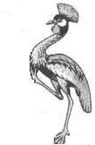 | - The crested crane is the Uganda’s national emblem. It signifies the gentleness and peaceful nature of the people of Uganda.  - Its drawn when it is in motion to show that Uganda is moving forward in terms of development  Why the crested crane was chosen to be Uganda’s national emblem.  - It is a beautiful bird.  - It is a gentle bird.  - It is a graceful bird.  - It is a peaceful bird.

THE NATIONAL FLAG AND COAT OF ARMS OF KENYA.
 | 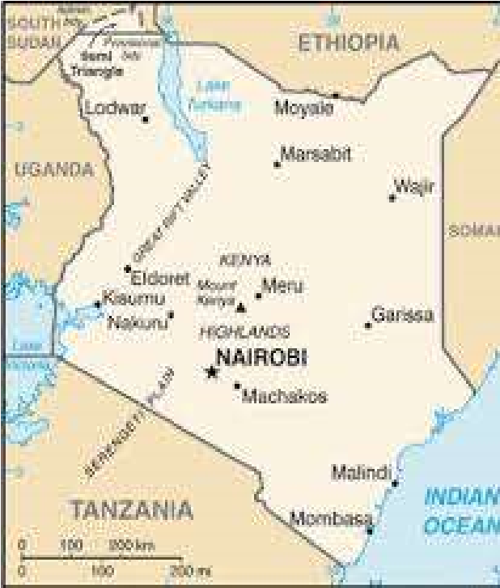 | 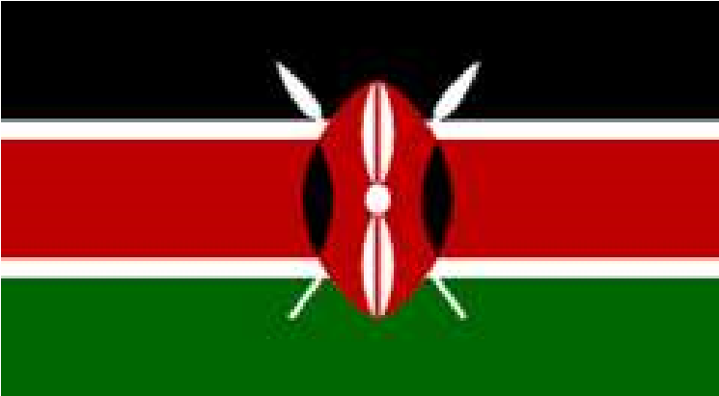 |  | 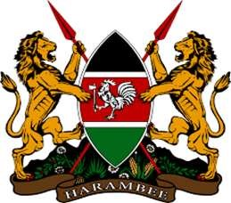
Features on the Kenya national flag and their meaning.  - Black colour represents the people of Kenya who are predominant Africans.  - ------- colour represents the peace enjoyed in Kenya. [White]  - Red colour represents the blood that was shed during the struggle for independence.  - Green colour represents the land and its agricultural potential.  - Shield and spears represents the traditional weapons and readiness to defend and protect the country. |  |  | Features on the Kenya national coat of arms and their meanings.  - Lions holding spears symbolises the--------, ability and strength of Kenyans to defend their country against external attacks. [courage, fierce]  - ---------- symbolises the party that led Kenya to independence. [Cockerel]  - Shield shows Kenya’s readiness to defend her independence.  - Agricultural products represent Kenya’s rich fertile soils.  - The motto ”Harambee” is a call for people to cooperate and work together in building the nation.

THE NATIONAL FLAG AND COAT OF ARMS OF TANZANIA.
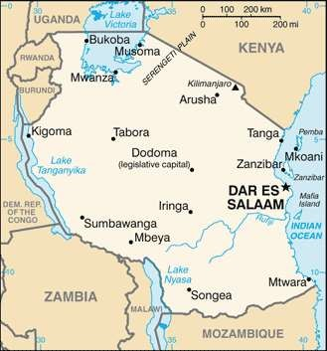 | 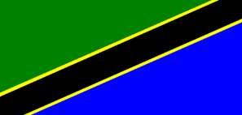 | 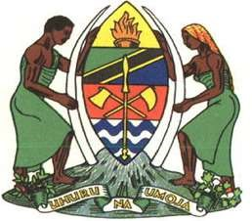

Features of the Tanzania national flag and their meaning  - Black colour represents the African race of Tanzanians.  - Green colour represents the abundant vegetation and fertile land of Tanzania.  - Blue colour represents the various lakes, rivers and other water bodies found in Tanzania.  - ---------- represents the different minerals and other wealth found in Tanzania. [Golden colour] | Features of the Tanzania coat of arms and their meaning.  - Golden colour represents the numerous minerals and other wealth which are found in Tanzania.  - Red colour represents the fertile soils on which different crops are found.  - ---------- represents the different water bodies found in Tanzania. [Blue waves]  - Burning torch represents the freedom, independence and enlightment of the people of Tanzania.  - Spear and shield represents the readiness of Tanzanians to protect and defend their country.  - ----------- represent the determination of Tanzania to promote agricultural development. [Axe and hoe]  - Cotton and cloves represents the traditional cash crops of  Tanzania. They also represent Tanzania as an agricultural country.  - Man and woman each holding an elephant tusk: represents the cooperation of Tanzanians to develop their country.  - The motto of Tanzania: “Uhuru na umoja” means freedom and unity.

THE NATIONAL FLAG AND COAT OF ARMS OF RWANDA.
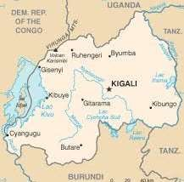 | 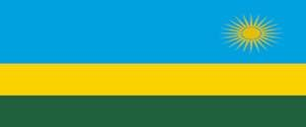 | 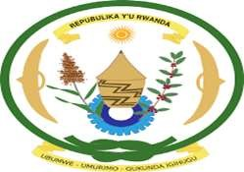

Features on the Rwanda national flag and their meaning.  - Blue colour reperesents the peace and happiness enjoyed in Rwanda.  - Yellow colour represents the economic development and mineral wealth.  - Green colour represents Rwanda as an agricultural country with abundant vegetation.  - The sun represents unity and enlightment of the people of Rwanda. | Features on the Rwanda national coat of arms and their meaning.  - ------------ represents the determination of Rwandans to develop through hard work.  - Sorghum and coffee represents the agricultural potential of Rwanda.  - Basket represents the traditional handcrafts,culture of saving, solidarity and sharing.  - --------- represents Rwanda’s readiness to develop in the field of science,technology and industry.  - ------- represents the traditional means of defence. They also represent patriotism and the people’s readiness to defend the country.  - The motto of Rwanda “Ubumwe, Umurimo,Gukunda Iguhugu”  (Unity,work,and patriotism) represents the determination of Rwandans to work together in order to develop their country.  Use the words below to fill in the missing spaces.  [ Shields, Green ring with a knot, Cog wheel]

THE NATIONAL FLAG AND COAT OF ARMS OF BURUNDI.
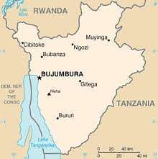 | 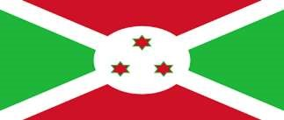 | 

- Features on the Burundi national flag and their meaning  - Green colour represents the abundant natural resources in Burundi.  - White colour represents hope and peace.  - Red colour represents international brotherhood.  - The three stars represents the three ethnic groups in Burundi ,the Hutu,Tusti and Batwa. | - Features on the Burundi national coat of arms.  - Shield and spears represents the readiness of the people of Burundi to defend and protect their country.  - National motto: Burundi’s motto is in French.”Unite Travail Progres”(Unity,Work,Progress.): it represents the unity and determination of the Burundians to work hard for the progress of their country.
THE NATIONAL FLAG AND COAT OF ARMS OF SOUTH SUDAN.
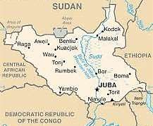 | 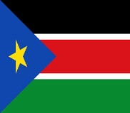 | 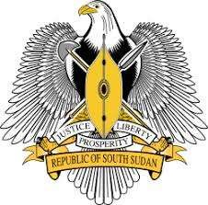
..
Features on the national flag of South Sudan and their meaning.  - Black colour represents the African race of the people of South Sudan.  - Red colour represents the blood that was shed in the liberation struggle.  - Green colour represents the fertile land and natural resources.  - Blue colour represents the waters of River Nile.  - Yellow star represents the unity of states making up South South Sudan. | Features on the national coat of arms of South Sudan and their meaning.  - African fish eagle represents the people’s resilience, vision and majesty.  - Shield and two spears represents the people’s readiness to protect their country.  - The motto: “Justice, Prosperity and Equality .” represents the people’s aspirations to live in a fair and just society in their country.

Importance of national symbols
[national, countries, unity, patriotism]
- They promote ------------ identity.
- They make countries look different from other-------------.(they are used as symbols of identification.)
- They promote national ------------- eg.the anthem.
- They promote ----------- among people.
- They are used as symbols of independence.

The neighbouring countries of the EAC
Country | Capital City | Direction
• Republic of Sudan | ------------- | • North
• Mozambique | • Maputo | • South
------------------- | • Lilongwe | • South
• Democratic Republic of Congo | • Kinshasa | • West
• Ethiopia | • Addis-Ababa | • North West
• Somalia | ------------------ | • East
• Central African Republic (C.A.R) | • Bangui | • North West
• ------------------- | • Lusaka | • South West

[Khartoum, Malawi , Mogadishu, Zambia ]

MEGA ACTIVITY

- Give any three ways the East African Community has promoted trade in East Africa.
i) __________________________________________________________________________
ii) __________________________________________________________________________
iii) _________________________________________________________________________
- Mention any three symbols of the East African Community.
i) _________________________ ii) ______________________ iii) _____________________
- Write down the East African Community motto.
____________________________________________________________________________
- What does the blue colour symbolize on the East African Community flag?
____________________________________________________________________________
- Mention any two occasions when the East African Community anthem is normally sung.
i) __________________________________________________________________________
ii) __________________________________________________________________________
- Give the English meaning of the phrase “Jumuiya ya Afrika Mashariki”.
____________________________________________________________________________
- Give one way a national anthem is important to a country.
____________________________________________________________________________
- What do the following features symbolise on the Uganda national coat of arms?
  - The Kob ___________________________________________________________________
  - The drum ___________________________________________________________________
  - Coffee and cotton ____________________________________________________________
  - (iv) The sun ________________________________________________________________

- Match correctly
colours of the Uganda flag | what they represent
black | peace enjoyed in Uganda
white | dark-skinned people of Uganda
yellow | international brotherhood
red | abundant sunshine received in Uganda
Black _______________________________________________________________________
White ______________________________________________________________________
Yellow _______________________________________________________________________
Red__________________________________________________________________________
- Who designed the Uganda flag?
____________________________________________________________________________
- How is the Uganda flag important to Ugandans?
____________________________________________________________________________
- Why is the crested crane drawn in motion?
____________________________________________________________________________
- ---------------------------signifies the gentleness and peaceful nature of the people of Uganda.
- Why was the crested crane chosen to be Ugandans national emblem?
____________________________________________________________________________
- Who designed the Uganda coat of arms
____________________________________________________________________________
- What do the following represent on the Uganda coat of arm?
The drum ____________________________________________________________________
Coffee and cotton _____________________________________________________________
The green hill _________________________________________________________________
The kob _____________________________________________________________________
The sun ______________________________________________________________________
- Mention any three features on the Kenya national flag and what they represent.
i) _________________________ ii) ______________________ iii) _____________________
- What do the following represent on the Kenya coat of arms
Lions ______________________________________________________________________
Shield _____________________________________________________________________
Agricultural products _______________________________________________________
Cockerels ___________________________________________________________________
- Give any two values of national symbols.
i) __________________________________________________________________________
ii) __________________________________________________________________________
- Complete the table below.
The neighbouring countries of the EAC
Country | Capital City | Direction
• | • Khartoum | • North
• Mozambique | • | •
• Malawi | • | • South
• | • Kinshasa | •
• Ethiopia | • | • North West
• Somalia | • Mogadishu | • East
 | • Bangui | •
• Zambia | • | • South West
- Name the colours on the national flag of DRC and give what they stand for.
i) __________________________________________________________________________
ii) __________________________________________________________________________
iii) _________________________________________________________________________
- What do the stars show on the DRC national flag?
___________________________________________________________________________
- Write down what the features below represent on the DRC coat of arms
Leopard ____________________________________________________________________
Elephant husk _______________________________________________________________
Spear _______________________________________________________________________
The national motto ___________________________________________________________

- What do the colours on the national flag of south Sudan represent?
___________________________________________________________________________
- Name the feature on the national coat of arms of south Sudan that shows peoples readiness to defend their country.
___________________________________________________________________________
- Mention all the features of the south sudan national flag and what they represent.
___________________________________________________________________________
- What does the word ” Travail Progress” mean?
___________________________________________________________________________
- Mention any three features on the Rwanda national flag.
i) _______________________ii) ____________________ iii) ________________________
- Name any four features of the Rwanda coat of arm and their meanings.
i) ________________________________ ii) ______________________________________
iii) _______________________________ iv)______________________________________
- Mention any three colours of the Burundi national flag and what they represent.
i) _______________________ii) ____________________ iii) ________________________

SESSION SEVEN
ATTEMPT ME AFTER THIS SESSION
- Match correctly
Types of history meaning
Anthropology analysis of languages spoken by people
Linguistic study of remains of people of long ago
Written history analysis of languages spoken by people oral tradition past events put in writing.
Anthropology _______________________________________________________________
Linguistic ___________________________________________________________________
Written history ______________________________________________________________
Oral tradition _______________________________________________________________
- Name the type of history shown in the picture below
Country | Name of museum
Uganda | -Uganda museum at Kitante
 | -Dar-es-salaam
Kenya | -
Rwanda | -Butare museum
 | -Burundi geological museum
South Sudan

- Draw and name any one source of written history in the space below

- Complete the table below.
Types of remains | information got
weaponry
statues of gods and temples
 | activities done
dwellings and tombs

HOW TO USE THIS KNOWLEDGE IN MY DAILY LIFE (RELEVANCE AND FUNCTIONALITY):
Helps learners appreciate the shared ancestry and common characteristics that unite all humans, promoting empathy, respect and inclusivity

COMPETENCES.
Describes Origin of human beings
Understand sources of history
Describes the archaeological site

WHAT I ALREADY KNOW (BACKGROUND KNOWLEDGE)
Legends

KEY LEARNING PRINCIPLE.
History refers to the study of things of long ago / past events

LEARNER CENTRED APPROACH.
Imagine you want to keep information of what has happened at home so that you don’t forget it and you tell it to your parents when they return, how would you keep it not to forget it.
The methods you have mentioned above are some clear examples of sources of history for people kept it for future use.

CONTENT

THE PEOPLE OF EAST AFRICA.

THE ORIGIN OF HUMAN BEINGS.
------------ is the study of past events. [History, Archeology]
History contains what man did, the way he lived, the tools he used and the way he adopted to the environment where he lived.
It is through history that we can trace the origin of man.

Sources of history.

Fill in the missing letters
- Oral traditions
- Li- -uis-ics
- Arch- -ology
- Written history
- Ant-ro-olo-y

Stages of evolution of man | 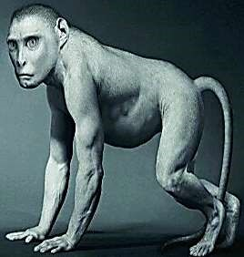  Homo habilis man
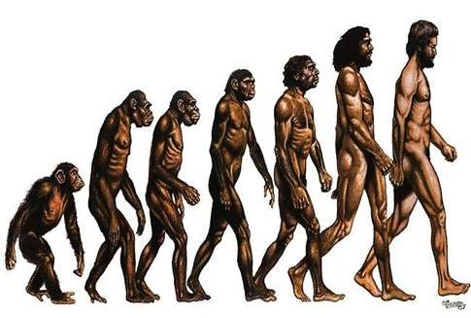

a) ORAL TRADITIONS
------------ history refers to information about the past that is passed on from one generation to another by the word of mouth. [oral, written]
It is the oldest form of keeping information.

Sources of Oral history.
Fill in the missing letters
- L-g-nds • Pro-er-s • Songs • Ri- -les • Poems • Tongue twisters

Advantages of oral traditions.
[cheap, respect, illiterates]
- It is --------- in terms of getting information.
- It promotes ---------- for elders.
- It encourages thinking among people.
- It favours the -------- and the blind.

Disadvantages of oral traditions.
[Information, memory]
- ----------- can easily be changed.
- Information can easily be lost in case a person with information dies.
- Information depends on one’s----------- .

b) WRITTEN HISTORY
This is the information about the past that is put into writing.
The period before written history was referred to as ----------------- period. [pre-historical, pre-colonial]

Sources of written history.
Fill in the missing letters.
- Textb- - ks • Ma-azi-es
- Newspapers • Jou- -als

Advantages of written history
- Information can be kept for future use or--------------.
- Information can not be ------ out.
- Information can not easily be changed.
- It gives the time when the events happened.
[reference, phased]
Note: Written history is the most accurate source of information.

Disadvantages of written history.
[expensive, illiterates, information]
- It is ----------- to record information.
- It caters for ----------- only.
- Some history may be changed by writers.
- It takes a long time to correct wrong ------------ .

- LINGUISTICS.
This is the study and analysis of languages ------------- by different people. (spoken)
---------------- can help us tell when and how the languages spoken now in East Africa came into existence. [Linguistics, languages]

- ANTHROPOLOGY.
Use the words below to complete the sentences.
(culture, Anthropology, beliefs, cultural)
This is the study of people’s-----------.
----------- is the social science that studies the origins and social relationships of human beings.
Anthropologists give information about ------------- systems like the ideas, ------ and institutions.

- ARCHAEOLOGY.
This is the scientific study of remains of people of long ago.
It is carried out by archaeologists.

Terms related to archaeology.
Fosils are remains of animals, plants and of humans of long ago.

Examples of fossils.

Name these examples of fossils.

Diagram of Skulls of People | ---------------------
Diagram of Caves | ---------------------
Diagram of Weapons | ---------------------
Diagram of Rock paintings | ---------------------
Diagram of Tools | ---------------------

Choose the correct answer from the list below.
- Skulls of People • Caves • Tools
- Bones of animals and people • Rock paintings • Weapons

------------- is the process of digging up the remains of early man. After excavation the remains are carbon dated to determine their age.

------------ dating is the arrangement of the fossils to determine their age.

--------------- is the grouping of fossils and arte-facts according to the depth of the ground where they are found.
---------------- are remains of items used by people of long ago.

[Excavation, Carbon, Stratification, Arte-facts]
Places where fossils and arte-facts are found.
- Museums - archaeological sites.

Mini activity.
- Match correctly
Types of history meaning
Anthropology analysis of languages spoken by people
Linguistic study of remains of people of long ago
Written history analysis of languages spoken by people oral tradition past events put in writing.
Anthropology _______________________________________________________________
Linguistic ___________________________________________________________________
Written history ______________________________________________________________
Oral tradition _______________________________________________________________
- Name the type of history shown in the picture below
Country | Name of museum
Uganda | -Uganda museum at Kitante
 | -Dar-es-salaam
Kenya | -
Rwanda | -Butare museum
 | -Burundi geological museum
South Sudan

- Draw and name any one source of written history in the space below

- Complete the table below.
Types of remains | information got
weaponry
statues of gods and temples
 | activities done
dwellings and tombs

Famous archaeologists in East Africa.
- Dr.Louis Leakey

(archaeologist, Leakey, Zinjanthropus, black, Olduvai Gorge)
He is the most prominent ---------------- in East Africa.
He came to East Africa with his wife Mary-----------.
Dr.Louis Leakey discovered the oldest skull of man at ----------------- in Tanzania in 1959.
This skull was believed to be for a man he named---------------.
The name Zinjanthropus is formed by two words;ie.”Zenj” which means black and “anthropus” which means man.
Therefore, the name “Zinjanthropus” means ------------ man.

Note: East Africa is therefore referred to as the cradle of mankind because the oldest skull of man was discovered in East Africa.

- Dr. Merrick Posnansky.
- He made his discoveries in the former Chwezi empire at in Sembabule district. [Bigobyamugenyi]

- Dr. Peter Schmidt.
- He carried out his discoveries in the --------------- in Northern Tanzania around the shores of Lake Victoria. [iron age sites, stone age sites]

- James.S Kirkman and Neville Chittick.
- He carried out ------------ work along the coast of East Africa( in the Zenj empire)
- They excavated the remains of the Portuguese along the coast of East Africa. e) Dr.Richard Leakey.
- He discovered the remains of early man around lake ---------- in Kenya.
- He was a son to Louis and ----------- Leakey.
[archaeological, Turkana, Mary]

Importance/ advantages of archaeology.

[employment, ancestors, origin]
- It is a source of --------------to people.
- It helps us to know the life style of our------------.
- It helps us to know the ------------ of mankind.

Problems facing archaeology.
- Shortage of to facilitate the activities. [funds. Money]
- Difficulty in locating sites for effective-----------. [excavation, extraction]
- Shortage of ------------ labour. [skilled, skilled]

MUSEUMS.
- A museum is a building where things of art, ---------- and ----------are kept for public viewing. [culture, history]

Examples of museums in East Africa.
Country | Name of museum
Uganda | -Uganda museum at Kitante -Kabale museum
Tanzania | -Dar-es-salaam -Arusha museum.
----------- | -Nairobi museum -Fort Jesus
Rwanda | -Butare museum -Ruhengeri museum.
-------------- | -Burundi geological museum -Gitega museum.
------------- | -National Archive museum.
(Kenya, Burundi, South Sudan)

Importance of museums in a country.

[local, employment, foreign, purpose]
- They create market for --------- craft materials.
- They provide ----------- to the people.
- They attract tourists who bring in ---------- exchange.
- The are used for research and education------------ .
- They keep arte-facts safe.

MINI ACTIVITY.
1. Draw the symbol of an archaeological site.

2. Give the difference between archaeology and anthropology.
____________________________________________________________________________
____________________________________________________________________________
3. Use a table to summarize the contributions of all the archaeologist who worked in East Africa

4. Mention any three advantages of stone age sites in East Africa.
i) __________________________________________________________________________
ii) __________________________________________________________________________
iii_ _________________________________________________________________________
5. How is Dr Louis Leakey remembered in the history of East Africa?
____________________________________________________________________________
6. Outline any two challenges facing the archaelogists in East Africa.
i) __________________________________________________________________________
ii) __________________________________________________________________________
7. Write short notes about:
Dr Louis Leakey _____________________________________________________________
Dr Merick Posnansky _________________________________________________________
Dr Richard Leakey ___________________________________________________________
Dr peter Schmidt ____________________________________________________________
James S Kirkman ____________________________________________________________
Neville Chittick ______________________________________________________________
8. Why is East Africa called the cradle of man kind?
____________________________________________________________________________
ARCHAEOLOGICAL /HISTORICAL SITES IN EAST AFRICA.
---------------- sites are places where the remains of early/people of long ago were discovered. (Archaeological)
Most archaeological sites in East Africa are found near lakes and rivers.

Reasons why most archaeological sites are found near lakes and rivers.
- Early man lived near lakes and rivers in order to get-----------. (water, food)
- Early man lived near lakes and rivers to ------ animals that came to drink water. [trap, hunt]
- Early man lived near lakes and rivers in order to get--------. [fish, frogs]

Famous archaeological sites in East Africa.
Country | Archaeological site.
Tanzania | -Olduvai Gorge -Apis Rock -Cheke -Kisese -Isimila -Lake Eyasi-Kondoa
Uganda | -Bigobyamugenyi -Paraa -Sango bay -Nyere rock paintings -Magosi -Ntusi.
Kenya | -Rusinga island -Kanjera -Yala Alego -Olorgesaile -Kanana -Kariandusi -Lewa.
Rwanda | -Nyungwe forest.

A sketch map showing stone age sites in East Africa.
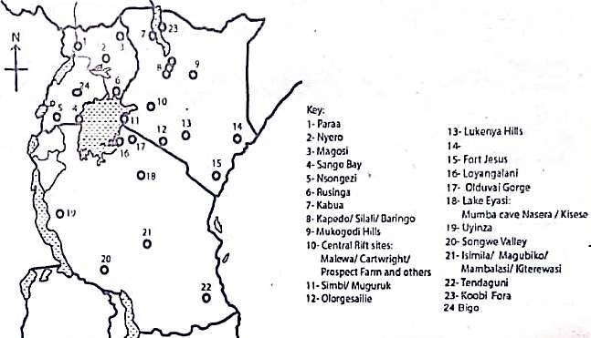

Ways archaeologists found places of fossils (archaeological sites).
- By digging unusual bumps and ------------- on the ground.
- By recognising the -------- and pieces of pottery.
- Ordinary people could find remains during their activities.

[hollows, footmarks]

Importance of archaeological/historical/stone age sites.

[attract, employment, research, trace]
- They -------- tourists who bring in income.
- They provide -------- to people.
- They promote culture in the society.
- The are used for ----------- and study purpose.
- They help people ------ their origin.
- They help us to know how our ancestors lived. The activities that were carried out by early man.

MEGA ACTIVITY
- Mention any three advantages of stone age sites in East Africa.
i) __________________________________________________________________________
ii) __________________________________________________________________________
iii) _________________________________________________________________________
- How is Dr Louis Leakey remembered in the history of East Africa?
____________________________________________________________________________
- Outline any two challenges facing the archaelogists in East Africa.
i) __________________________________________________________________________
ii) __________________________________________________________________________

- Write short notes about:
Dr Louis Leakey _____________________________________________________________
Dr Merick Posnansky _________________________________________________________
Dr Richard Leakey ___________________________________________________________
Dr peter Schmidt ____________________________________________________________
James S Kirkman _____________________________________________________________
Neville Chittick ______________________________________________________________
- Why is East Africa called the cradle of man kind?
____________________________________________________________________________
- How is are facts different from fossils?
____________________________________________________________________________
____________________________________________________________________________
- Give the difference between linguistics and anthropology.
____________________________________________________________________________
____________________________________________________________________________
- What does the word archaeology mean?
____________________________________________________________________________
- Define excavation.
____________________________________________________________________________
- Mention any two places where art facts are found.
i) _________________________________ ii) _______________________________________
- Differentiate carbon dating and stratification.
____________________________________________________________________________
____________________________________________________________________________
- Mention any two disadvantages of written history over oral tradition.
i) __________________________________________________________________________
ii) __________________________________________________________________________
- What is meant by history?
____________________________________________________________________________
- Why is it of value for children to learn history?
____________________________________________________________________________
- Mention any two sources of history
i) __________________________________ ii) _____________________________________
- Outline any two sources of oral history.
i) __________________________________ ii) ______________________________________
- Give any two advantages of oral traditions over written history.
i) __________________________________________________________________________
ii) __________________________________________________________________________
- Mention any two sources of written history apart from text books.
i) ___________________________________ ii) ____________________________________
- What does” Zenj” mean?
____________________________________________________________________________
- Where was the oldest skull of man discovered?
___________________________________________________________________________

THE STONE AGE

Stone age was the period when man used stones to make his----------.[ tools]
The stone age period was called so because early man made his tools out of stones.
Man was called the stone age man because man made his tools out of stones.

Stages of development during the stone age.
- Old/ -----------/ Palaeolithic Stage.
- ----------- / New/ Neolithic Period.
- Middle/ ---------/ Period.
[Mesolithic, Early, Late]

The Old Stone age.
- This was the first stage of stone age.
- It is also called ----------------- / early stone age. [Palaeolithic]

Characteristics of early man in the Old stone age.
[permanent, naked, hairy, molar]
- Man had no -------- home.
- He moved------- .
- Man had a --------body.
- He used simple tools out of stones.
- Man lived a wondering life.
- Man had huge --------- teeth for grinding hard food.

➢ Note:-The discovery of fire marked the end of the Old stone age and the beginning of the Middle stone age.

The Middle stone age.
Early man started it with the discovery of fire. He rubbed a dry stick into a hole in a dry piece of wood. As a result of friction, fire was produced.
The Middle stone age is also called the Mesolithic.

Characteristics of early man in the Middle stone age.
- Man started using better --------. [Tools]
- Man started eating ------meat. [roasted]
- Man started living in -----.[caves]
- Man tamed a dog for hunting and protection.
- Man started hunting animals using -------.[traps]
- Man started using skins as blankets.

Ways fire was useful to early man.
[protection, roasting, warmth, boiling]
- Fire was used for ---------against wild animals.
- Fire was used for --------- meat.
- Fire provided light in caves.
- Fire provided ------------ to early man in caves.
- Fire was used for ---------- poison.
- Fire helped man to harden his tools.

Note:The discovery of farming marked the end of the Middle stone age and the beginning of the New stone age.

The New stone age.
- Early man started it with the discovery of…………...
- It is also called the late stone age/ ………...
[farming, neolithic]

Characteristics of early man in the New stone age.
Huts, communities, farming, life
- Early man started to live in simple…………..
- Early man started living in………...
- Early man started carrying out………..
- Early man lived a settled ……..

Note: Farming enabled early man live a settled life because he had to settle and take care of his crops.

Ways early man obtained/got his food.
Hunting, gathering, wild
- By………...
- By collecting wild honey.
- By ………… fruits.
- By fishing.

Examples of early man’s food.
- Wild honey • Fish • Fruits • Raw meat

Mini activity
1. Draw the first animal to be tamed by man

2. State any three differences between the man of old stone age and that of the new stone age.
____________________________________________________________________________
____________________________________________________________________________
____________________________________________________________________________
____________________________________________________________________________
____________________________________________________________________________
3. Write short notes about the following terms
Palaeolithic man ____________________________________________________________
Neolithic man ______________________________________________________________

Examples of early man’s tools and their uses.
Name of tool | Drawing | Use of the tool to early man
Bolas |  | ❖
Hand axe |  | ❖ It was used for skinning animals. ❖ For digging up plant roots.
Hand spears |  | ❖ It was used for hunting
Bone needle |  | ❖ It was used for stitching animal skins and hides to make clothes
Wooden club
Bow and arrow

Note:The discovery of Iron smelting marked the end of Stone age period and the beginning of Iron age.

THE IRON AGE

This was the period when early man started using iron to make his tools.
Iron smelting was started by the ………. at Meroe in Ethiopia. [Cushites ]
It was introduced in East Africa by the…….. [Bachwezi]
Blacksmithing is the act of making and repairing iron tools.
A ………….. is a person who makes iron tools. [blacksmith]

Tools made from iron by blacksmiths.
- Knives • Spears • Saucepans • Pangas • Axe • Weaving needles
- Hoe • Sickle • Arrows.

Name the tools below.
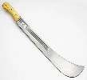 |  | 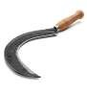 | 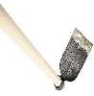 | 
…………… | …………. | ……….. | ……….. | ……….

How iron smelting changed the life of early man.
- It has enabled man to make better tools for ------- .This increased food production.
- It has enabled early man make better -------- for defence.
- It has helped man to make better means of -----------.
- It has enabled early man to make better fishing tools.

SESSION 8
ATTEMPT ME AFTER THIS SESSION
1. State any two causes of the bantu migration.
i) _____________________________________________________________________________
ii) _____________________________________________________________________________
2. Mention any three reasons why the bantu migrated from their cradle land into east Africa
i) _____________________________________________________________________________
ii) ____________________________________________________________________________
iii) ____________________________________________________________________________
3. How did the bantu migration positively affect the people of East Africa?
____________________________________________________________________________
4. Mention any two negative effect of the bantu migration to people of east Africa.
i) _____________________________________________________________________________
ii) _____________________________________________________________________________

HOW TO USE THIS KNOWLEDGE IN MY DAILY LIFE (RELEVANCE):
Understanding ethnic groups helps learners become more informed and engaged global citizens
COMPETENCES
Traces the origin and movement of different ethnic groups in East Africa
Bantu, Nilotics, Plain Nilotes ,Highland Nilotes ,Cushites/ Hamites ,Sudanic people
WHAT I ALREADY KNOW (BACKGROUND KNOWLEDGE)
Stages of early man development
Ethnic groups of East Africa
Factors that influence movement and settlement patterns of people in East Africa

KEY LEARNING PRINCIPLE.
An ethnic group is a large number of people with the same characteristics
LEARNER CENTRED APPROACH.
Looking at all kinds of people in the community, identify their languages, food they eat , beliefs, styles of dressing an traditional occupations.
State the difference and similarities that you have ever observed among them

ETHNIC GROUPS IN EAST AFRICA
An ……… group is a large group of people with the same origin, same traditional occupation and speak related languages [ethnic, tribal].
An ethnic group can also be known as a tribal group.
A …………… is a group of people who have the same origin and speak the same language. [tribe, tribal]
The Bushmen were the early inhabitants of East Africa before the coming of ethnic groups into East Africa. The Bushmen were displaced as a result of the ethnic migrations. The direct descendants of the Bushmen in East Africa are the Sandawe and Hadza in Northern Tanzania, the Pygmies in Uganda and Democratic Republic of Congo.
The first ethnic group to migrate into East Africa were the Cushites/Hamites.

Problems faced by ethnic groups during their migrations.
- Attacks from ---------- tribes.[ hostile]
- They were attacked by ---------- animals. [dangerous]
- Difficulty in crossing-------------. [terrains]
- Shortage of water and------------.[ pasture]
- Attacks from tropical diseases.

Major ethnic groups that came into East Africa.
Ethnic group | Cradle land (place of origin) | occupation
Bantu | Cameroon highlands | Cultivation
River-Lake Nilotes(Nilotics) | Bahr-el-Ghazal | ………………
Cushites (Hamites) | Ethiopia | ……………..
Plain Nilotes (Nilo-Hamites) | Ethiopian highlands | …………….
Highland Nilotes | Ethiopian highlands | …………….
Sudanic people | Juba (South Sudan) | Mixed farming.
Use the guidance below to complete the table.

Ethnic groups that settled in dry areas carried out pastoralism.
MINI ACTIVITY
- Mention any two characteristics of man in the middle stone age.
i) __________________________________________________________________________
ii) __________________________________________________________________________
- Name the first stage of development of man.
____________________________________________________________________________
- How did iron smelting help to improve the life of early man.?
____________________________________________________________________________
- How is a black smith different from black smithing?
____________________________________________________________________________
- Mention any two tools made by a black smith.
i) __________________________________________________________________________
ii) __________________________________________________________________________
- Who introduced black smithing in East Africa?
____________________________________________________________________________
- How did farming enable early man to live a settled life?
____________________________________________________________________________
- How is farming different from trade?
____________________________________________________________________________

Characteristics of Ethnic groups.
[languages, origin, occupation]
- People speak related------------.
- People have the same-------------.
- People carry out the same major-----------.

Factors that affected settlement patterns of ethnic groups into East Africa..
- Availability of land.
- Cli-at-
- W-te- bo-ies
- Na- -re of the Soil
- Ve- -t-tion
- Oc-u-ation

How the above factors influenced the settlement patterns of Ethnic groups in East Africa.
[climate, land, nature of the soil, vegetation, water bodies]

- ………: Most people settled in areas with favourable climate for their traditional; occupation. Areas that receive much rainfall attracted the cultivators while areas that receive low rainfall attracted cattle keepers.

- ---------------- The Bantu who were cultivators settled in the interlacustrine region which had fertile soils for crop growing.
- ---------: Most ethnic groups migrated into East Africa to acquire enough land for growing crops and rearing animals.
- Vegetation:
Most pastoral tribes settled in areas with savannah vegetation to get pasture for their animals.
- --------------: Most tribal groups settled around water bodies in order to get water for home use, for their animals and to carryout fishing.
- ------------ : Most ethnic groups in East Africa settled in areas that were suitable for their traditional occupation eg.the Bantu settled in areas that had fertile soils and received reliable rainfall which support crop growing, the Nilotics were pastoralists which made them settle in areas that had plenty of pasture for their animals.

A sketch map showing migration routes and settlement of Ethnic groups
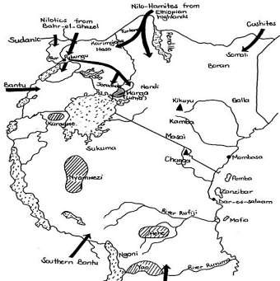

MEGA ACTIVITY
- What other name is used to mean Ethnic group?
_______________________________________________________________________________
- Who were the early inhabitants of East Africa before the Ethnic groups?
_______________________________________________________________________________
- Mention any two limitations the ethnic groups met on their migrations
i) _____________________________________________________________________________
ii) _____________________________________________________________________________
- Name the first ethnic group into East Africa.
_______________________________________________________________________________
- How is a tribe different from a clan?
______________________________________________________________________________________________________________________________________________________________
- Complete the table below correctly
Examples of early man’s tools and their uses.
Name of tool | Drawing | Use of the tool to early man
Bolas
Hand axe | 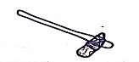
Hand spears
Bone needle |  | ❖ It was used for stitching animal skins and hides to make clothes
Cleaver |  | ❖ It was used for chopping meat
Wooden club
Bow and arrow |  | ❖ It was used for hunting and fishing

- Complete the table below.
Ethnic group | reason for its name
Bantu
plain Nilotes
Lake River Nilotes
Highland Nilotes
Cushites

THE BANTU.
- The Bantu forms the ---------- ethnic group in East Africa.
- The Bantu are called so because they speak related languages with a common suffix “ntu” when referring to people or things.
- The Bantu --------------from Cameroon highlands.
- Their major occupation is cultivation/ crop growing..
- They settled in the -----------region in East Africa.
[interlacustrine, originated, largest]
➢ N.B: Interlacustrine region is an area between the great lakes of East Africa.

Examples of interlacustrine lakes.
- Lake -ictori-
- Lake Ta- -anyika
- Lake Ki-u
- Lake E-wa-d
- Lake Al-ert.

Reasons why the Bantu settled in interlacustrine region.
[cultivation, reliable, inhabitants]
- The area had fertile soils suitable for--------------.
- The area received --------- rainfall that favour the growing of crops.
- The area had also had weak ----------- ie. the Bushmen.

Bantu groups that migrated to East Africa.
a) The Western Bantu.
- This was the first group of Bantu to enter East Africa. They entered East Africa through the West between Lake Albert and Lake Edward.

Mini activity
- Mention any two characteristics of ethnic groups.
i) ____________________________________________________________________________
ii) ___________________________________________________________________________
- The Bantu originated from,______________________________________________________
- Mention any two bantu groups that migrated to the East Africa.
i) ____________________________________________________________________________
ii) ___________________________________________________________________________
- Why are the bantu called so?
______________________________________________________________________________
- Name the place where the Bantu originated from.
_____________________________________________________________________________
- Name any two bantu tribe from Kenya.
- __________________________________ ii) _______________________________________

- The Highland and Coastal Bantu (Eastern Bantu).
This Bantu group settled around Mount………., Mount ………… and the coast of East Africa. (Kilimanjaro, Kenya)
Tribes under the Eastern Bantu
Country of settlement | Bantu tribe
Kenya | Kikuyu, -------, Taita, --------,Embu, Meru, Pokomo.
Tanzania | Chagga, Tareta, ----------, Washamba.
[Akamba, Mijikenda, Zaramo]

- The Western Tanzanian Bantu.
- They entered East Africa through …………. between Lake ……… and Lake Kivu and settled mainly in Tanzania. They include the………, Sukuma, Baziba, Gogo. [Tanzania, Tanganyika, Nyamwezi]

d) The Southern Bantu.
They entered East Africa through the South West between Lake Tanganyika and Lake Nyasa (Lake Malawi).
- They mainly settled in Tanzania. They include ; Yao, Hehe, Makonde, Makua, Fipa, Pogoro and Mwera.

THE NGONI.
[Zwangendaba, Ngoni]
The -----------was the last group of the Bantu to enter East Africa.
The Ngoni came from South Africa .
The Ngoni used the Southern route to enter East Africa.
The Ngoni were led by chief…………... They were running away from the wars of Shaka the king of the Zulu kingdom in South Africa, who attacked them.

Note:
- The dominant Bantu tribe in Rwanda and Burundi are the Hutu.
- Baganda is the largest Bantu tribe in Uganda .
- The Kikuyu is the largest Bantu tribe in Kenya.
- The Sukuma are the largest Bantu tribe in Tanzania.

Bantu tribes that settled on slopes of mountains in East Africa.
[Bafumbira, Chagga, Kenya]
Mountain | Bantu tribe
Mount Rwenzori | Bakonzo
Mount Mufumbiro | -----------, Bakiga
Mount Elgon | Bagishu
Mount Kilimanjaro | -----------
Mount --------------- | Kikuyu

Mini activity.
1. Give any two reasons why the bantu settled in the interacustrine region.
i) _____________________________________________________________________________
ii) _____________________________________________________________________________
2. Name the group of the bantu that came to Uganda?
_____________________________________________________________________________
3. Which bantu tribe dominates
Rwanda _______________________________________________________________________
Kenya _________________________________________________________________________
Tanzania _____________________________________________________________________
4. Name the last group of the bantu into East Africa
_____________________________________________________________________________
5. Mention any two tribes among the bantu that settled on the slopes of mountains.
i) ________________________________ ii) __________________________________________
6. How is mt Kilimanjaro related to the chagga?
_____________________________________________________________________________
7. Name the bantu group that entered East Africa through the southern route
_____________________________________________________________________________

Causes of the Bantu migrations.

(famine, epidemic, cultivation, cradle)

- Outbreak of ----------diseases in their cradleland.
- Internal and external conflicts.
- The need for fertile land for---------.
- Outbreak of---------------.
- Shortage of land.
- Over population in their ---------- land.
- Prolonged drought.

Reasons for the migrations of the Bantu into East Africa.
[pasture, external, cultivation, fertile]
- They were looking for water and ---------for their animals.
- They were escaping from --------- attacks.
- They were escaping from epidemic diseases which attacked them.
- To look for areas that received reliable rainfall.
- To look for enough land to carry out------------.
- To look for ---------- soils for crop cultivation.

Effects of Bantu migrations into East Africa.
a) Positive effects.
- They introduced new----------.
- They introduced new languages.
- They introduced new-----------.
- They introduced new ------------ systems.
- They formed ---------- and chiefdoms where they settled.

[crops, cultures, kingdoms, farming]

b) Negative effects.
- They displaced people where they settled ie. The Bushmen. They moved southwards and settled in the ---------- desert) [Kalahari, Sahara]
- Their ------------ led to loss of culture of the early------------. [intermarriages, inhabitants]
- -------------- increased in areas where they settled. [Population]
- They caused wars and conflicts in areas where they settled.

MINI ACTIVITY
1. State any two causes of the bantu migration.
i) _____________________________________________________________________________
ii) _____________________________________________________________________________
2. Mention any three reasons why the bantu migrated from their cradle land into east Africa
i) _____________________________________________________________________________
ii) ____________________________________________________________________________
iii) ____________________________________________________________________________
3. How did the bantu migration positively affect the people of East Africa?
____________________________________________________________________________
4. Mention any two negative effect of the bantu migration to people of east Africa.
i) _____________________________________________________________________________
ii) _____________________________________________________________________________

THE NILOTES.
[Nile, Nilotes]
The Nilotes are called so because they had their origin along the -------- valley.
The -------------are divided into three sub groups
Namely;
  - The River-Lake Nilotes.
  - The Highland Nilotes.
  - The Plain Nilotes/ Nilo-Hamites.

THE RIVER- LAKE NILOTES.
They are also called the Nilotics/---------- speakers. [Luo, Acholi]
They are called Luo speakers because they speak Luo as their language.
They migrated from in------------ South Sudan. [Bahr-el-Ghazal, Cameroon Highlands]
The Nilotics are sometimes referred to as River-Lake Nilotes because they settled near lakes and rivers.
The Nilotics entered into East Africa from Northern Uganda.
The Nilotics first settled at ----------- when they first reached Uganda.
Pubungu currently is known as Pakwach.
The Nilotics were led by Olum and his two sons -------- and Labongo.
The two brothers separated at Pubungu due to misunderstandings over the spear and the bead.
The Separation of the River-Lake Nilotes.
- The first group led by Gipir settled in the West Nile. They intermarried with the Lendu leading to the rise of the Alur tribe.
- The second group moved to areas North of lake Kyoga and settled there and these form the Acholi tribe.
- Another group moved southwards to Bunyoro. They were led by Isingoma Rukidi Mpuga. They intermarried with the Babiito clan and formed the Luo-Babiito dynasty.
- The last group moved eastwards, they formed the Jopadhola in Tororo district.
- Another group continued to Western Kenya forming the Jaluo tribe.

The Sub-groups under the Jaluo.
- Jok-omolo • Jok-owiny • Jok-ojok

Tribes under the River-Lake Nilotes/ Luo speakers in East Africa.
Al-r
Ja- -o in Kenya.
Jo- -d-ola
- -oli (the largest tribe under the Nilotics).

Effects of the migration of the Nilotes.
- Positive effects.
[Luo, domestic, chiefdoms, dynasty]
- They introduced -------language where they settled.
- The number of ------animals increased in East Africa.
- They formed ------------ where they settled.
- They introduced new crops such as millet, sorghum, and sweet potatoes in East Africa.
- They founded the Luo-Biito------------.
- They introduced new culture like pet names and Luo languages.

b) Negative effects.
- They --------- people where they settled.
- The Luo invasion led to collapse of Bunyoro------ empire.
- …………. increased where they settled which resulted into shortage of land.
[Kitara, displaced, Population]

MINI ACTIVITY.
1. Why are the nilotes called so?
_____________________________________________________________________________
2. Mention any two tribes under the River Lake Nilotes
i) ___________________________________ ii) ______________________________________
3. Name the three sub groups of the nilotes
i) ___________________________________ ii) _______________________________________
iii) ____________________________________________________________________________
4. How did the coming of the nilotes affect the people of East Africa?
_____________________________________________________________________________
5. How is pubungu historically important to the river lake nilotes?
_____________________________________________________________________________
6. Who founded the luo biito dynasty?
_____________________________________________________________________________

THE PLAIN NILOTES/ NILO-HAMITES.
[Ethiopian, pastoralism, Turkana, semi-arid]
They originated from the ………… highlands.
Their traditional occupation is----------.
They entered East Africa through the North around lake---------.
They entered Uganda through the North East.
They settled in the ---------- areas of East Africa.
In Uganda, they settled in the North Eastern part.
The Plain Nilotes today in Uganda settle in districts like Nakapiripirit, Moroto, Soroti, Katakwi, Kumi, Abim, Kaabong.

Reasons why the Plain Nilotes settled in plain areas.
- The areas were large without people.
- The areas were free from ------ like tsetse flies.
- The areas were free from………...
[vectors, tsetse flies]

Tribes under the Plain Nilotes in East Africa.
Country | Tribe
Uganda | Karimojong, Iteso, Langi, Jie, Kumam.
Kenya | Turkana, Masai,Samburu.
Tanzania | Masai, Barabaig, Tatoga.

Reasons why some tribes of the plain Nilotes changed to mixed farming.
[fertile, reliable, cultivators]
- They had settled in areas with ---------soils good for growing.
- The areas where they settled received ……… rainfall.
- They were influenced by the Bantu ----------- who were their neighbours.

MINI ACTIVITY
1. Why did the plain nilotes settle in plains?
_____________________________________________________________________________
2. Name the cradle land of the plain nilotes.
_____________________________________________________________________________
3. State any two tribes in Uganda under the plain nilotes
i) ____________________________________ ii) _____________________________________
4. Complete the table below
Country | Tribe
Uganda | .
 | Turkana, Masai,Samburu.
Tanzania
5. Why did the plain nilotes change from pastoralism to mixed farming?
_____________________________________________________________________________
THE HIGHLAND NILOTES.
They were originally--------------.[ pastoralists]
They originated from Ethiopian highlands and they settled around Mountain Elgon and Western highlands of Kenya.

Tribes under the Highland Nilotes.
Tribe | Country
-Sabiny -Pokot | Uganda
-Tugen -Nandi -Kipsigis -Marakwet etc | Kenya
-Dadong | Tanzania

Cause of the migrations of the Nilotes into East Africa.
[pasture, epidemic, population, cradle]
- Shortage of ----------for animals.
- Internal and external attacks.
- Outbreak of ---------diseases.
- High --------- which led to shortage of land.
- Prolonged drought in their --------- land.
- Outbreak of famine in their cradle land.

Reasons for the migrations of the Nilotes into East Africa.
[pasture, attacks, epidemic, pastoralism]
- They were looking for water and ----------for their animals.
- They were escaping from external………..
- They were escaping from --------- diseases which attacked them.
- To look for enough land to carryout--------------.
- Outbreak of animal diseases.

MINI ACTIVITY
1. From which direction did the highland nilotes enter Uganda?
_____________________________________________________________________________
2. Complete the table below
Tribe | Country
-Sabiny -Pokot
- | Kenya
-Dadong
3. How are the sabiny similar to the tugen in terms of ethnicity.
_____________________________________________________________________________
4. Why did the nilotes migrate to east Africa?
_____________________________________________________________________________

THE CUSHITES/ HAMITES.
- They are believed to have come from Asia and settled in countries found in the Horn of Africa. ie.Ethiopia, Somalia, Djibouti, and Eritrea.
- It was the first ethnic group to come into East Africa.
- They originated from Ethiopia into East Africa.
- In Uganda,the Hamites entered from the South West direction.

Tribes under the Cushites/ Hamites in East Africa.
Tribe | Country
-Bahima -Tutsi -Bahinda | Uganda
-Tutsi | Rwanda
-Tutsi | Burundi
-Kinje -Somali -Boran -Galla -Rendille. | Kenya
-Mbugu -Iragu | Tanzania

Causes of the migrations of the Cushites into East Africa.
[Prolonged, pasture, attacks, cradle]
- ------------ drought in their cradle land.
- Shortage of ---------for their animals.
- External ------------- from their neighbours.
- Outbreak of famine in their ------- land.

Reasons for the migratinons of the Cushites into East Africa.
[water, pasture, pastoralism, diseases]
- To look for --------for their animals.
- To look for --------for their animals.
- To look for enough land to carryout---------.
- To look for safe areas from pests and -----------.

Effects for the coming of Cushites into East Africa.
[horned, displaced, population, smelting]
- The Cushites introduced long …………. cattle.
- The Cushites ……… people where they settled.
- The Cushites increased ………… in East Africa.
- They introduced the idea of iron ………… in East Africa.
MINI ACTIVITY.
1. Name the first ethnic group to come to East Africa.
_____________________________________________________________________________
2. Why did the cushites migrate to East Africa?
_____________________________________________________________________________
Complete the table below
- Tribe | Country
-Bahima -Tutsi -Bahinda
- | Rwanda
-Tutsi
- | Kenya
-Mbugu -Iragu

THE SUDANIC PEOPLE.
The Sudanic people are believed to have migrated from Juba in South Sudan.
They settled in the West-Nile sub-region of Uganda.
They carried out -------- farming. [mixed]

Tribes under the Sudanic in East Africa.
- Lu-bara • Ma-i
- O-ebu • Len-u

Problems faced by Ethnic groups during their migrations.
[attacks, food, physical]
- --------- from hostile people.
- Shortage of ………and water.
- Difficulty in crossing some ………… features e.g. rivers.

MEGA ACTIVITY.
1. Give one way the discovery of iron smelting improved early man’s life.
______________________________________________________________________________
2. Complete the table below correctly.
Ethnic group | Origin | One tribe in each country
Ethnic group | Origin | Uganda | Kenya | Tanzania
(i) Bantu | ______________ | ______________ | -------- | ---------
(ii) ______________ | ______________ | Sabiny | -------- | ---------
(iii) _____________ | ______________ | ______________ | Masai | ---------
(iv) Cushites | Ethiopia | ______________ | -------- | ---------
3. What is an Ethnic group?
______________________________________________________________________________
4. Give any two reasons why the Bantu settled in the interlacustrine region.
i) ____________________________________________________________________________
ii) ___________________________________________________________________________
5. Mention one Bantu tribe that lives on the slopes of the following mountains.
Mountain Rwenzori ____________________________________________________________
Mountain Kilimanjaro__________________________________________________________
(iii) Mountain Elgon ___________________________________________________________

6. State any four causes for the migration and settlement of the ethnic groups into Uganda.
i) ____________________________________________________________________________
ii) ___________________________________________________________________________
iii) ___________________________________________________________________________
iv) ___________________________________________________________________________
7. How did the migration of the Bantu into East Africa affect the Bushmen?
______________________________________________________________________________
8. Mention the three sub-groups of the Nilotes.
i) ____________________________________ ii) ______________________________________
iii) ___________________________________________________________________________
9. How did the Alur tribe come into existence in East Africa?
______________________________________________________________________________
10. Name the place where the River-Lake Nilotes first settled in East Africa.
______________________________________________________________________________
11. State any three ways the migration of the Nilotes affected the people of East Africa.
i) ____________________________________________________________________________
ii) ___________________________________________________________________________
iii) ___________________________________________________________________________
12. Mention any three tribes under the Sudanic in East Africa.
i) ____________________________________ ii) ______________________________________
iii) ___________________________________________________________________________
13. Outline any two challenges ethnic groups face during migration.
i) ____________________________________________________________________________
ii) ____________________________________________________________________________
14. Give the origin of the ethnic groups below.
Highland Nilotes ____________________________________________________________
Nilo Hamites _________________________________________________________________
Hamites ______________________________________________________________________
River Lake Nilotes ______________________________________________________________
15. Mention any two examples of interlacustrine lakes.
i) _________________________________ ii) _________________________________________
16. Why did the Bantu settle in the Interlacustrine region?
______________________________________________________________________________
17. Write short notes about
The western Tanzania Bantu ____________________________________________________
The southern Bantu ____________________________________________________________
18. Complete the table below
Tribe | Country
-Sabiny -Pokot
- | Kenya
 | Tanzania
19. Complete the table below.
Mountain | Bantu tribe
 | Bakonzo
Mountain Mufumbiro | Bafumbira , Bakiga
Mountain Elgon
 | Chagga
Mountain Kenya

20. Why did the Plain Nilotes settle in plain areas?
______________________________________________________________________________
PROJECT WORK
Using a piece of paper , pencil and colours , Draw a map of East Africa showing migration routes and settlement patterns of Ethnic groups into East Africa.
RESEARCH WORK.
Write about ways of living of people of East Africa in the past and in the present.
Discuses and write about wys of worship of people in the past and today in East Africa.

